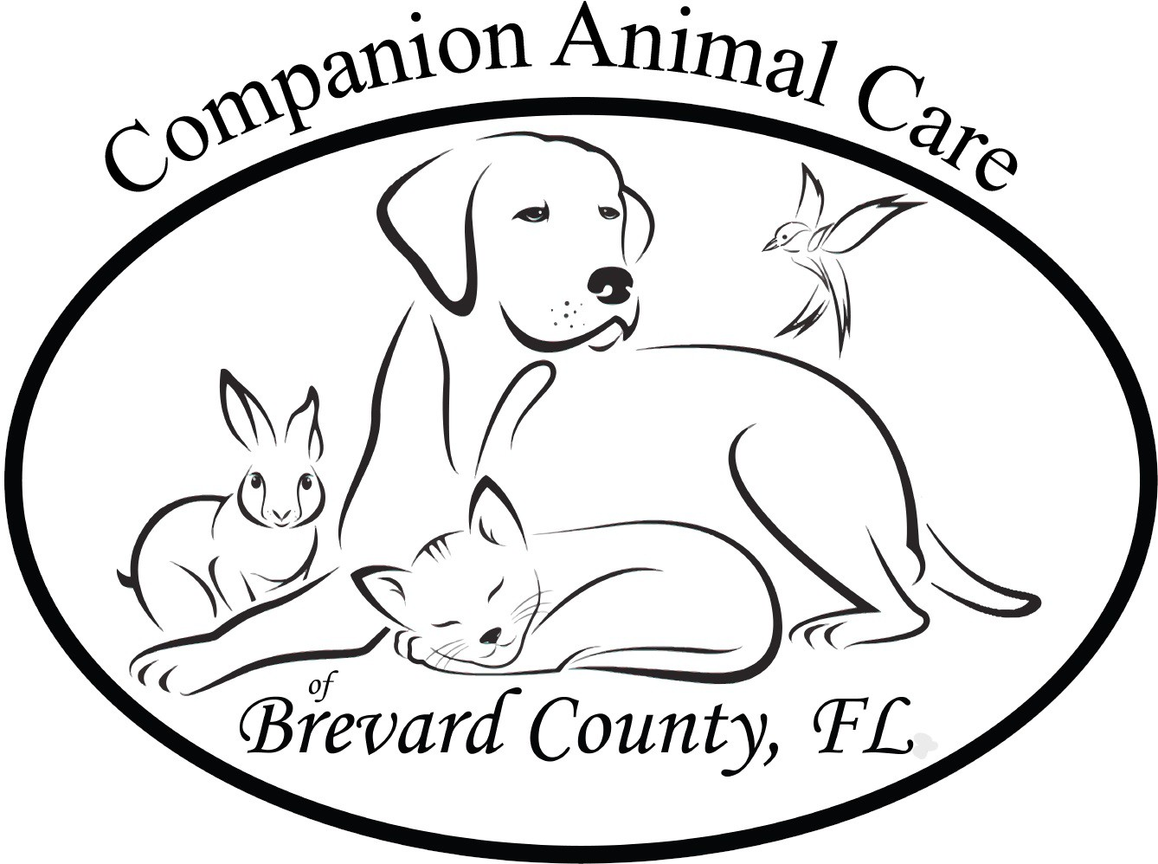Companion Animal Care of Brevard County

P.O. Box 3604196, Melbourne, FL, 32936 www.companionanimalcarebcfl.org info@companionanimalcarebcfl.org

**PET OWNER/CARETAKER** **FORM:** **Surrender (** **)**  **Foster** **Care** **(** **)**

Pet Owners Name:

Owners Address: City: State: Zip:

Owners Phone: Email:

Caretakers Name if Different then Owner: Relationship:

Caretakers Address: City: State: Zip: _______

Caretakers Phone: Email:

Do you have the authority to surrender/foster pet? Explain:

Owner Admitted to/or: ( ) Hospice ( ) Nursing Home ( ) Memory Care ( ) Assisted Living ( ) Rehab ( ) Deceased (Please provide corresponding paperwork to identity which facility the owner has been admitted to or attach Obituary)

Name of Pet(s): _________________________________ Age: __________________ Date of Birth: ________________

Breed: ________________________________ Markings: ______________________________

Is pet licensed: ( ) Yes ( ) No – License Number Year: Where:

Medical Records Attached: ( ) Yes ( ) No – If No, Are they Available ( ) Yes ( ) No Location of Records:

Is pet micro chipped: ( ) Yes ( ) No # Name of Micro Chip Registration:

Did you get your pet from a rescue or animal shelter? If so please list name and location/date:

Does this rescue/shelter/adoption service have any claim to this pet ( ) Yes ( ) No - Explain:

Housebroken ( ) Yes ( ) No – Paper-trained ( ) Yes ( ) No - Crate/Litter Trained ( ) Yes ( ) No - Has Accidents ( ) Yes ( ) No Where did the pet sleep at night: Kept during the day:

How does the pet behave when left alone:

Was your pet kept confined to your property: Fenced area ( ) Yes ( ) No - Cable/chain ( Yes ( ) No - Not confined

Does the Pet jump fences: ( ) Yes ( ) No - Height of fencing: Type of fencing:

Pets favorite activities:

Has the pet lived in the same household with other: Dogs ( ) Yes ( ) No – Cats ( ) Yes ( ) No – Birds ( ) Yes ( ) No Children: Ages: Other pets/Kind:

How did this pet get along with family members/children:

Is there anything you would like to tell us or explain to us:

I hereby certify that I am the rightful owner/keeper/caretaker/custodian/executor of the pets(s) who is/are the subject of this pet Owners Surrender/Foster form, hereinafter referred to as “pet.” I hereby surrender all property rights to this pet described. This is a **surrender application**: Please Initial . This is **temporary foster care** for my pet please Initial:

I certify that no other person has a right of property to this pet. I also certify and attest that there are no outstanding fee's, penalties, fines or any other financial obligations attached to or associated to this pet and if there are, I affirm my personal liability to them up to the date of surrender of this pet to Companion Animal Care of Brevard County, Inc.

I understand that by surrendering my property rights to this pet, the pet will be transferred into the custody of Companion Animal Care of Brevard County, Inc who may place the pet into one of their approved foster homes, keep the pet inhouse, or may adopt the pet into an approved “forever” home. (Only if this is a Surrender Application Form)

I also hereby certify that the animal has/has not [circle one] (bitten) or (scratched) a human or another animal within the past 10 days and is under no quarantine, surrender or court order.

I understand that once I relinquish the pet, the pet will not be available to be returned. I further certify that I have read and understand the terms of this Animal Surrender/Foster Form.

I further authorize the examining veterinarian to provide and discuss any medical issues, concerns, or results from past or current physical examinations of this pet with Companion Animal Care of Brevard County, Inc.

Printed Name of ( ) Owner ( ) Caretaker)

Signature Date

Companion Animal Care of Brevard County, Inc. Representative Name

Signature Date

# Veterinary Statement of Care/Health

Name of Veterinary Hospital/Facility:

Address City State Zip

Phone Email

Name of Care/Examining Veterinarian and Hospital if different then above:

Please List the Vaccination Shot Record and Dates for the Pet or attached medical records: (Must Be Current)

Please List the Health/Medical condition/Issues of this Pet and your statement of health and/or recommendations:

Heart-worm ( ) Positive ( ) Negative - Date of Test - Parasite ( ) Positive ( ) Negative Date of Test

**Feline** immunodeficiency virus (**FIV**) ( ) Positive ( ) Negative - Date of Test

Comments: Such as any medical conditions or issues that we should be aware of:

Signature of Examining Veterinarian Date